**Graded Assignment on Testing, Linux and Servers**

**📑 Report: DevOps Development Environment Setup**

**🧑‍💻 Problem Context**

As a Fresher DevOps Engineer assisting Rahul (Senior DevOps Engineer), I implemented system monitoring, secure user management, and automated backup configurations for two developers (Sarah and Mike).  
The goal was to ensure **system health visibility, secure access, and data recovery mechanisms**.

**Task 1: System Monitoring Setup (15 Marks)**

**Steps:**

1. **Install monitoring tools:**
2. Sudo yum update
3. sudo yum install htop nmon -y
   * htop: Interactive CPU/memory/process monitoring.
   * nmon: Detailed performance data.

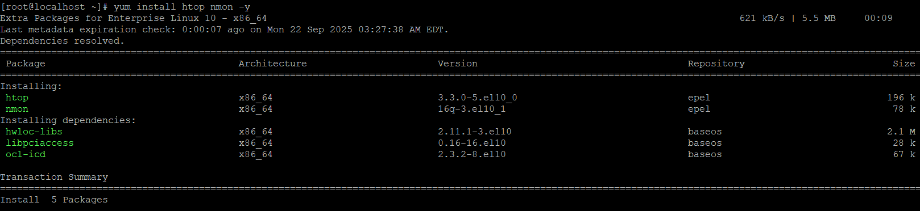

1. **Disk usage monitoring:**
2. df -h # Shows overall disk usage

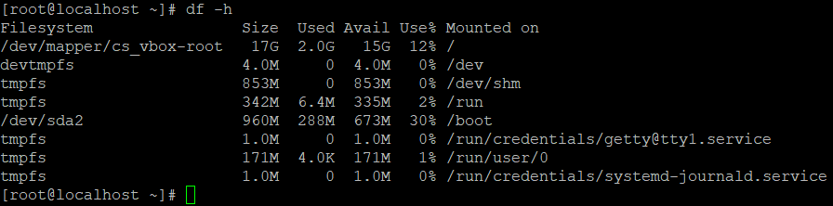

1. du -sh /home/* # Shows per-user directory usage

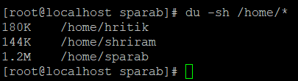

1. **Identify resource-intensive processes:**
2. ps aux --sort=-%cpu | head -n 10

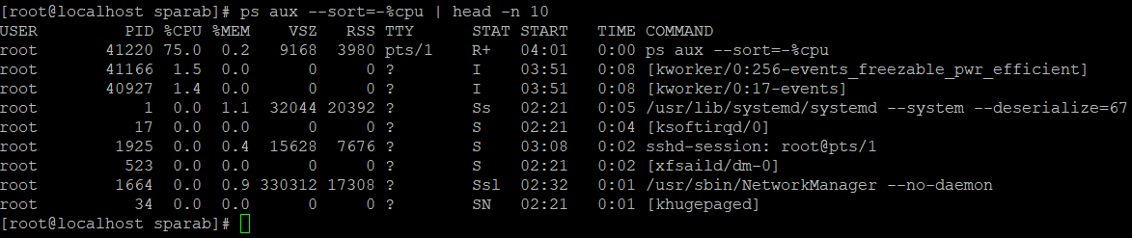

1. ps aux --sort=-%mem | head -n 10

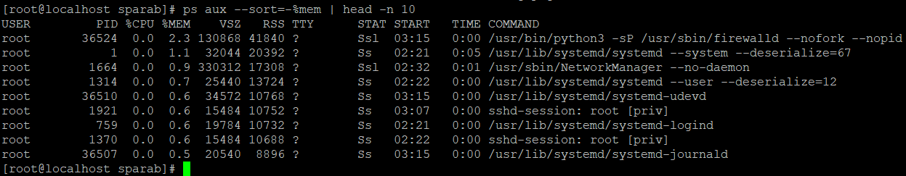

1. **Save outputs to logs for reporting:**
2. mkdir -p /var/log/Sysmon



1. top -b -n 1 > /var/log/sysmon/htop_$(date +%F).log



1. df -h > /var/log/sysmon/disk_$(date +%F).log



1. ps aux --sort=-%cpu | head -n 10 > /var/log/sysmon/topcpu_$(date +%F).log

✅ **Deliverables:**

* Logs in /var/log/sysmon/
* Screenshots of htop, df, and top processes

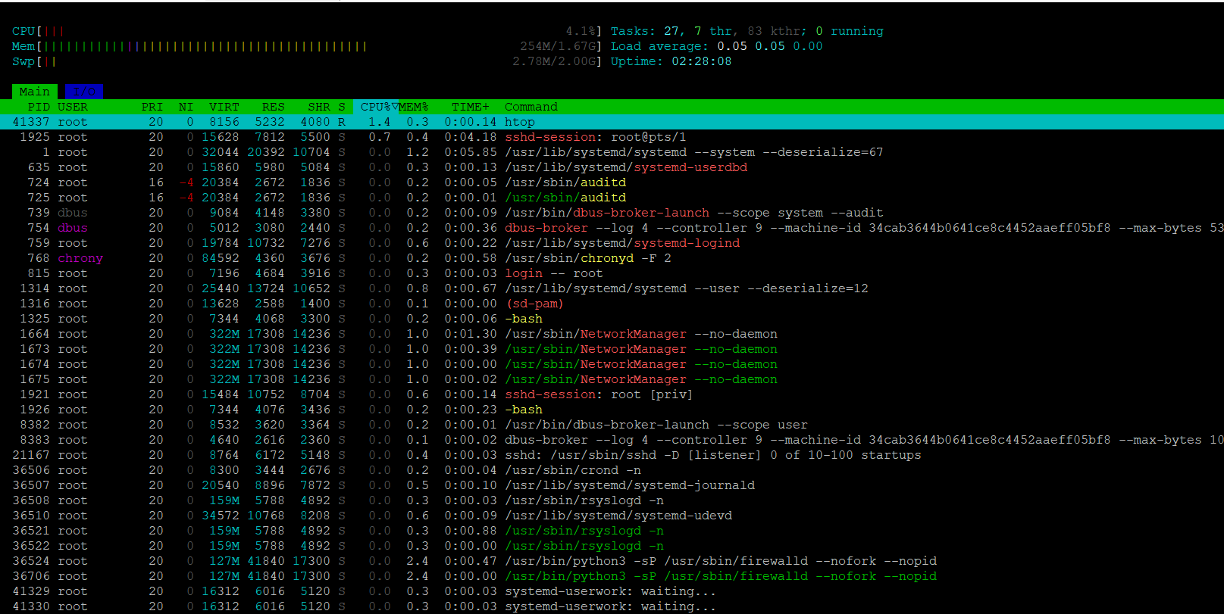

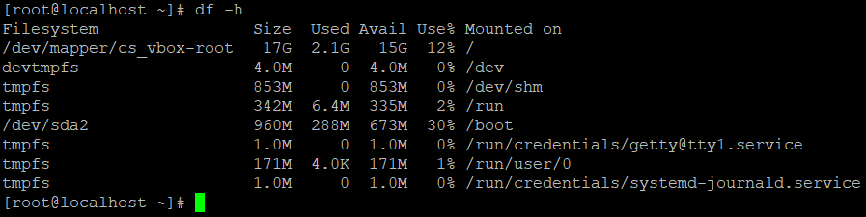

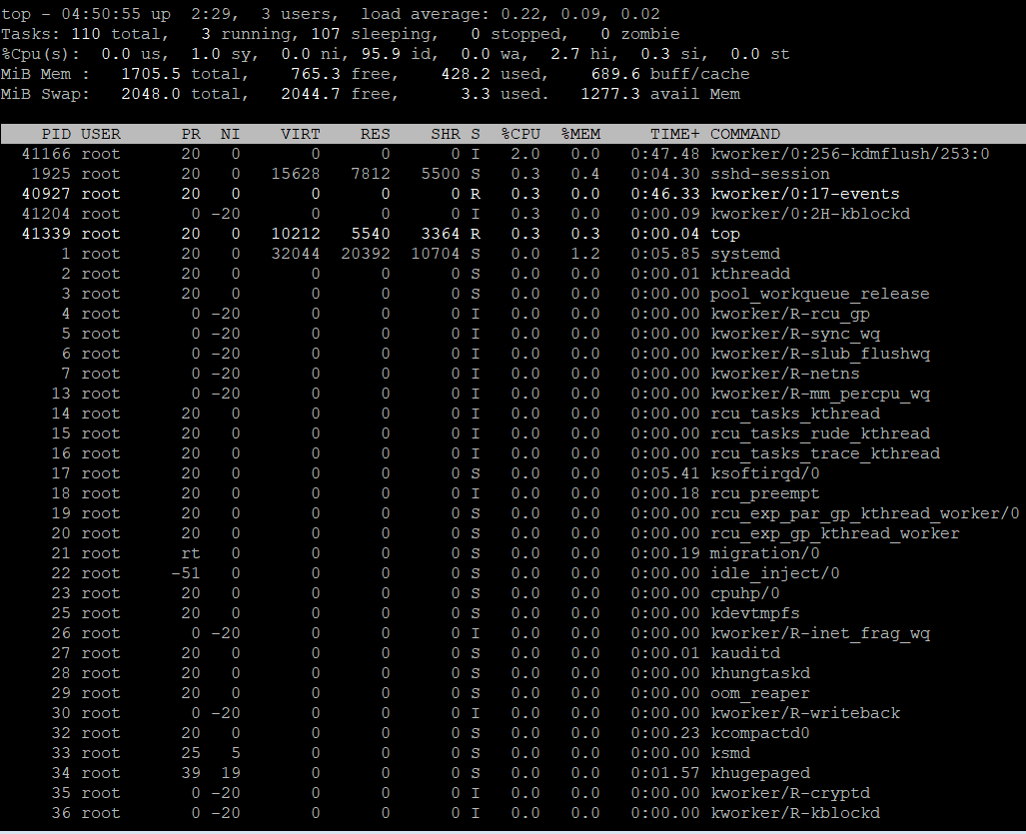

**Task 2: User Management & Access Control (10 Marks)**

**Steps:**

1. **Create user accounts:**
2. sudo adduser Sarah
3. sudo adduser Mike



1. **Set secure passwords:**
2. sudo passwd Sarah
3. sudo passwd Mike

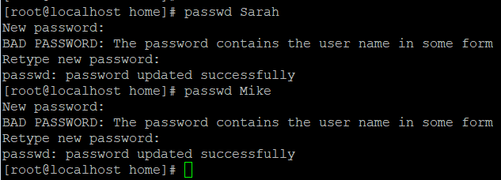

1. **Create isolated workspaces:**
2. mkdir -p /home/Sarah/workspace
3. mkdir -p /home/Mike/workspace



1. chown Sarah:Sarah /home/Sarah/workspace
2. chown Mike:Mike /home/Mike/workspace



1. chmod 700 /home/Sarah/workspace
2. chmod 700 /home/Mike/workspace



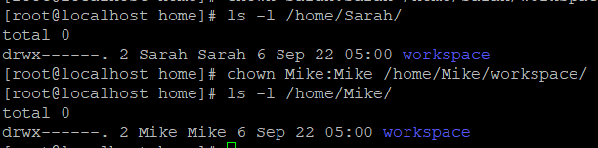

Isolation verified with below activity

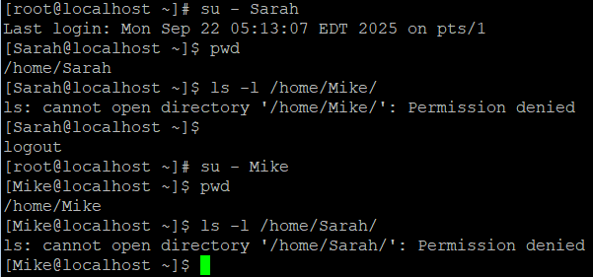

1. **Enforce password policy:**  
   Edit /etc/login.defs:

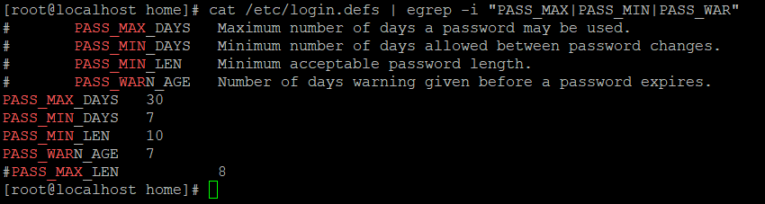

1. PASS_MAX_DAYS 30
2. PASS_MIN_DAYS 7
3. PASS_MIN_LEN 10
4. PASS_WARN_AGE 7

Apply immediately:

sudo chage -M 30 Sarah

sudo chage -M 30 Mike

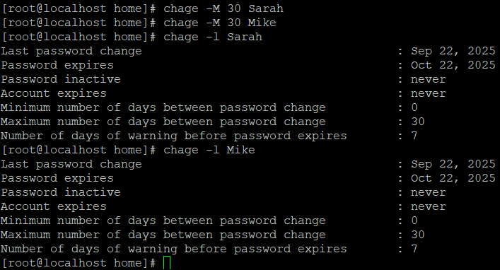

✅ **Deliverables:**

* User accounts created
* Workspace isolation verified
* Password policies in place

**Task 3: Backup Configuration for Web Servers (20 Marks)**

**Steps:**

1. **Create backup directory:**
2. sudo mkdir -p /backups
3. sudo chmod 755 /backups

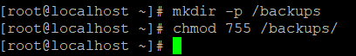

1. **Backup scripts:**

**Sarah (Apache):** /usr/local/bin/apache_backup.sh

#!/bin/bash

BACKUP_DIR="/backups"

DATE=$(date +%F)

FILE="$BACKUP_DIR/apache_backup_$DATE.tar.gz"

tar -czf $FILE /etc/httpd/ /var/www/html/

tar -tzf $FILE > $BACKUP_DIR/apache_verify_$DATE.log

sudo chmod +x /usr/local/bin/apache_backup.sh

**Mike (Nginx):** /usr/local/bin/nginx_backup.sh

#!/bin/bash

BACKUP_DIR="/backups"

DATE=$(date +%F)

FILE="$BACKUP_DIR/nginx_backup_$DATE.tar.gz"

tar -czf $FILE /etc/nginx/ /usr/share/nginx/html/

tar -tzf $FILE > $BACKUP_DIR/nginx_verify_$DATE.log

sudo chmod +x /usr/local/bin/nginx_backup.sh

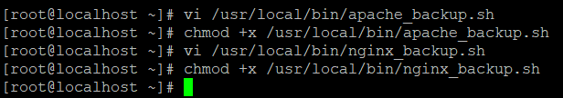

1. **Schedule cron jobs (every Tuesday at 12:00 AM):**
2. crontab -e

Add entries:

0 0 * * 2 /usr/local/bin/apache_backup.sh

0 0 * * 2 /usr/local/bin/nginx_backup.sh

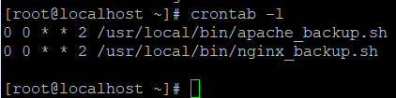

1. **Verify backup integrity:**
2. ls /backups/

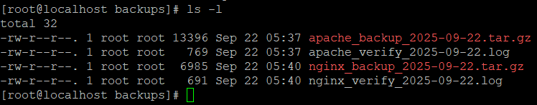

1. cat /backups/apache_verify_2025-09-22.log

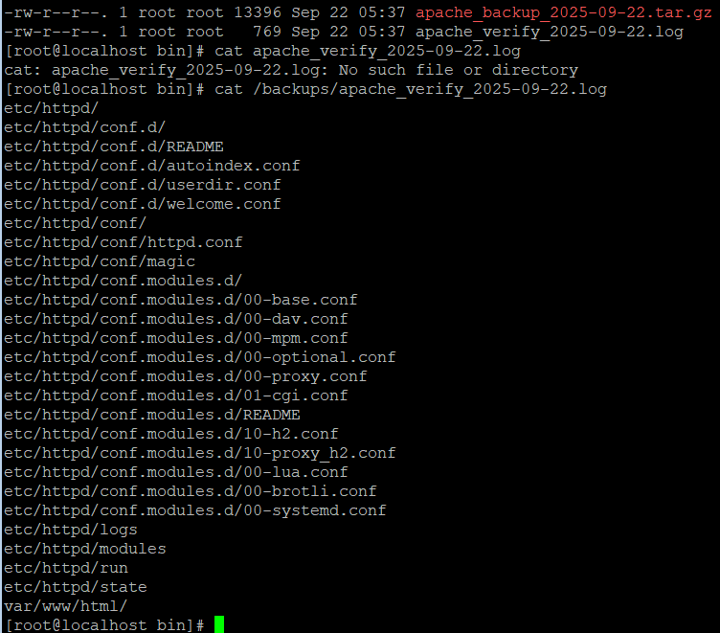

1. cat /backups/nginx_verify_2025-09-22.log

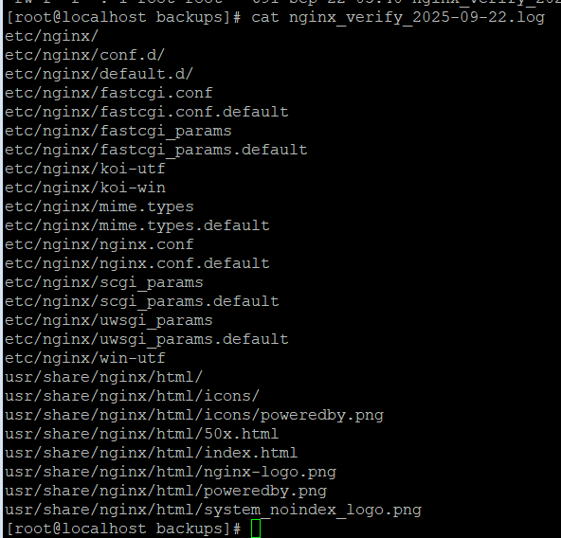

✅ **Deliverables:**

* Backup files in /backups/
* Verification logs proving data integrity
* Cron job configuration

**📊 Overall Challenges & Learnings (5 Marks)**

* Ensuring **permissions isolation** without blocking user productivity.
* Writing **robust backup scripts** with verification logs.
* Learned how to use **htop, nmon, df, du, ps** effectively for real-time monitoring.
* Implemented **password aging policies** to enforce security compliance.
* Automated backups using **cron jobs**, ensuring disaster recovery readiness.